|  |  |  |  |  |  |  |
| --- | --- | --- | --- | --- | --- | --- |
| EUFOR LOGO FINAL 11 | | | **PROCUREMENT AND CONTRACTING OFFICE**  HQ EUFOR, J8  BUTMIR Camp Sarajevo  Bldg. 225, 71210 Ilidza, BH  Fax: Civil +387-33-495707  e-mail: [taco@eufor.europa.eu](mailto:taco@eufor.europa.eu) | EUFOR LOGO FINAL 11 | | |
|  |  | | |  |

**CLARIFICATION 1**

**Invitation to bid for Supply and delivery of furniture and mattress to HQ EUFOR Camp Butmir Sarajevo, BiH**

Publication reference: HQ EUFOR/FURNITURE & MATTRESS/2022-SU/004

- In accordance with Article 2. and Article 12. of Instruction to bidders, requests for clarification are to be received by the 22 July 2022, 16:00 hr. and clarification to be issued by the Contracting Authority by 29 July 2022. The following clarification questions have been received, followed by the Contracting Authority’s answers:

**Question 1**

Please clarify following for item number 3:

METAL BED

1. Do the bidders offer a double bed in the amount of 100 pieces for this item (which would be for 200 people), because there is a double bed in the photo in part of your documentation, or according to the description, the bidders should offer for one person?
2. Is it obligatory for the bed to have a net floor or is it allowed to offer a bed as in the photo below?

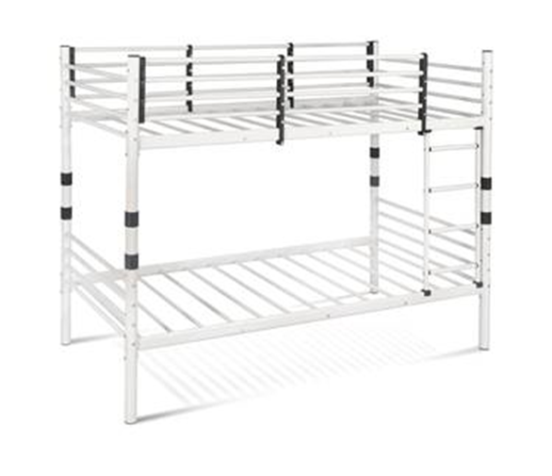

**Answer 1**

Line item 3. Metal bed, clarification is as follows:

1. Request is for a single bed that is collapsible and bankable (possibility to fit bed on the top of other bed ), request is for a 100 single beds.
2. Frame for matrass (floor) has to be as required - Metal grid 10X10 cm.

**Question 2**

Could you kindly advise if at place of delivery you have your own means (forklifts or man power) for unloading our trucks?

**Answer 2**

HQ EUFOR Warehouse Butmir Camp Sarajevo, is equipped with own means (manpower and forklifts) for unloading the trucks.

Procurement and Contracting Office

J8, HQ EUFOR

15 July 2022

This clarification is being sent simultaneously to all bidders and published on following website: [www.euforbih.org/tenders](http://www.euforbih.org/tenders) where bidding dossier is published. No further clarifications may be required nor provided as specified by clause 12 of the instructions to Bidder.