PROCUREMENT AND CONTRACTING OFFICE
HQ EUFOR, J8
BUTMIR Camp Sarajevo
Bldg. 225, 71210 Ilidza, BH
Fax: Civil +387-33-495707
e-mail: taco@eufor.europa.eu

CLARIFICATION 2

INVITATION TO BID FOR SUPPLY AND DELIVERY OF OFFICE FURNITURE TO HQ EUFOR, CAMP BUTMIR SARAJEVO

Publication reference: HQ EUFOR/OFFICE FURNITURE/2021-SU/002
- In accordance with modified IFB Article 2. and Article 12. of Instruction to bidders, requests for clarification are to be received by the Wednesday, 14 April 2021, 16:00hr. The following clarification questions have been received, followed by the Contracting Authority’s answers:

Question 1.Technical specifications, Line item 1, Rotary chair
Earlier wasn't stated that we need to provide sample for item 1., Rotary chairs. By sample, do you mean the whole chair or sample of materials? If it needs to be the whole chair, there is no enough time to provide a sample, as we don't have all types of chairs on stock. Also, does the sample (whole chair) needs to be provided with the submission of bids or can be delivered later?

Answer 1: Technical specifications, Line item 1, Rotary chair
In accordance with Instructions to bidders, Article 20.4. The contract will be awarded to the lowest priced bidder, while being administratively and technically compliant. Companies that pass administrative and technical evaluation and offer equivalent product, will be requested in writing to provide sample (whole chair), before the award decision is made. Sample is not required in this phase of bidding process.

Question 2.
Can we submit our bid as a community with other bidders (JOINT VENTURE BID)?
If the answer is yes, please tell us how we make the offer, because we are talking about two legal entities based in different countries.

Answer 2:
Please follow the instruction provided in IFB, Instructions to bidders, Article 18. Joint venture or consortium.

Question 3. Technical specifications, Line item 7, Small table
Please clarify metal frame you are requesting. Do you want top panel to be inserted in metal frame or top panel can be just attached to the metal legs?

Answer 3: In accordance with Technical specifications, Line item 7, Small table, please find the picture of requested table.

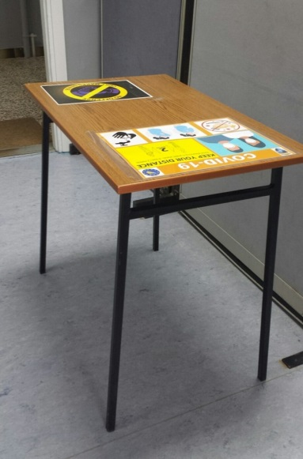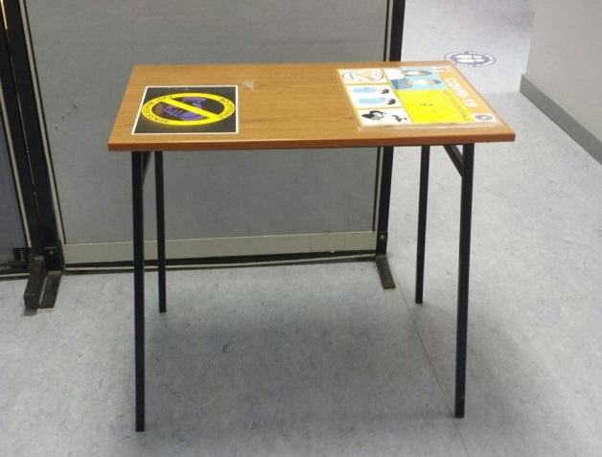

Procurement and Contracting Office
J8, HQ EUFOR
22 April 2021

This clarification is being sent simultaneously to all bidders and published on following website: www.euforbih.org/tenders where bidding dossier is published. No further clarifications may be required nor provided as specified by clause 12 of the instructions to Bidder.

